CSE 4/6283 Software Testing and Quality Assurance

Assignment 4
Test-Driven Development & Unit Testing

Members:

Jon Williams JDW751

GitHub:
https://github.com/JoshuaQChurch/SoftwareTesting

Lessons learned

Benefits

Drawbacks

Screenshots

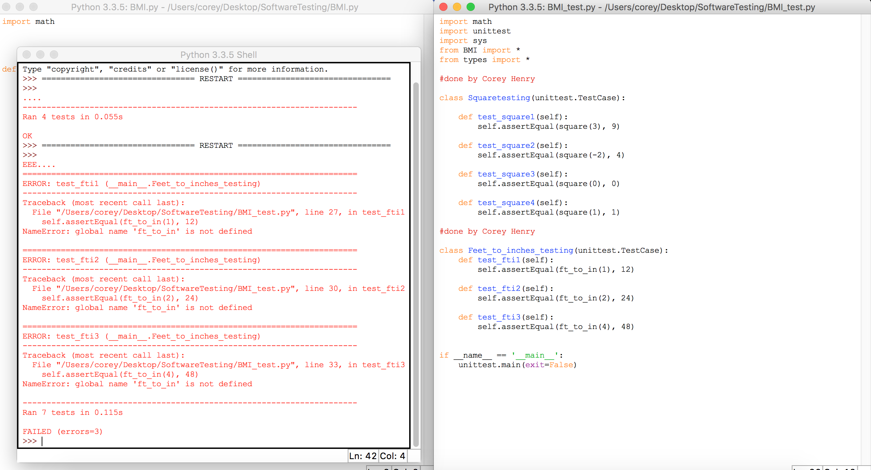
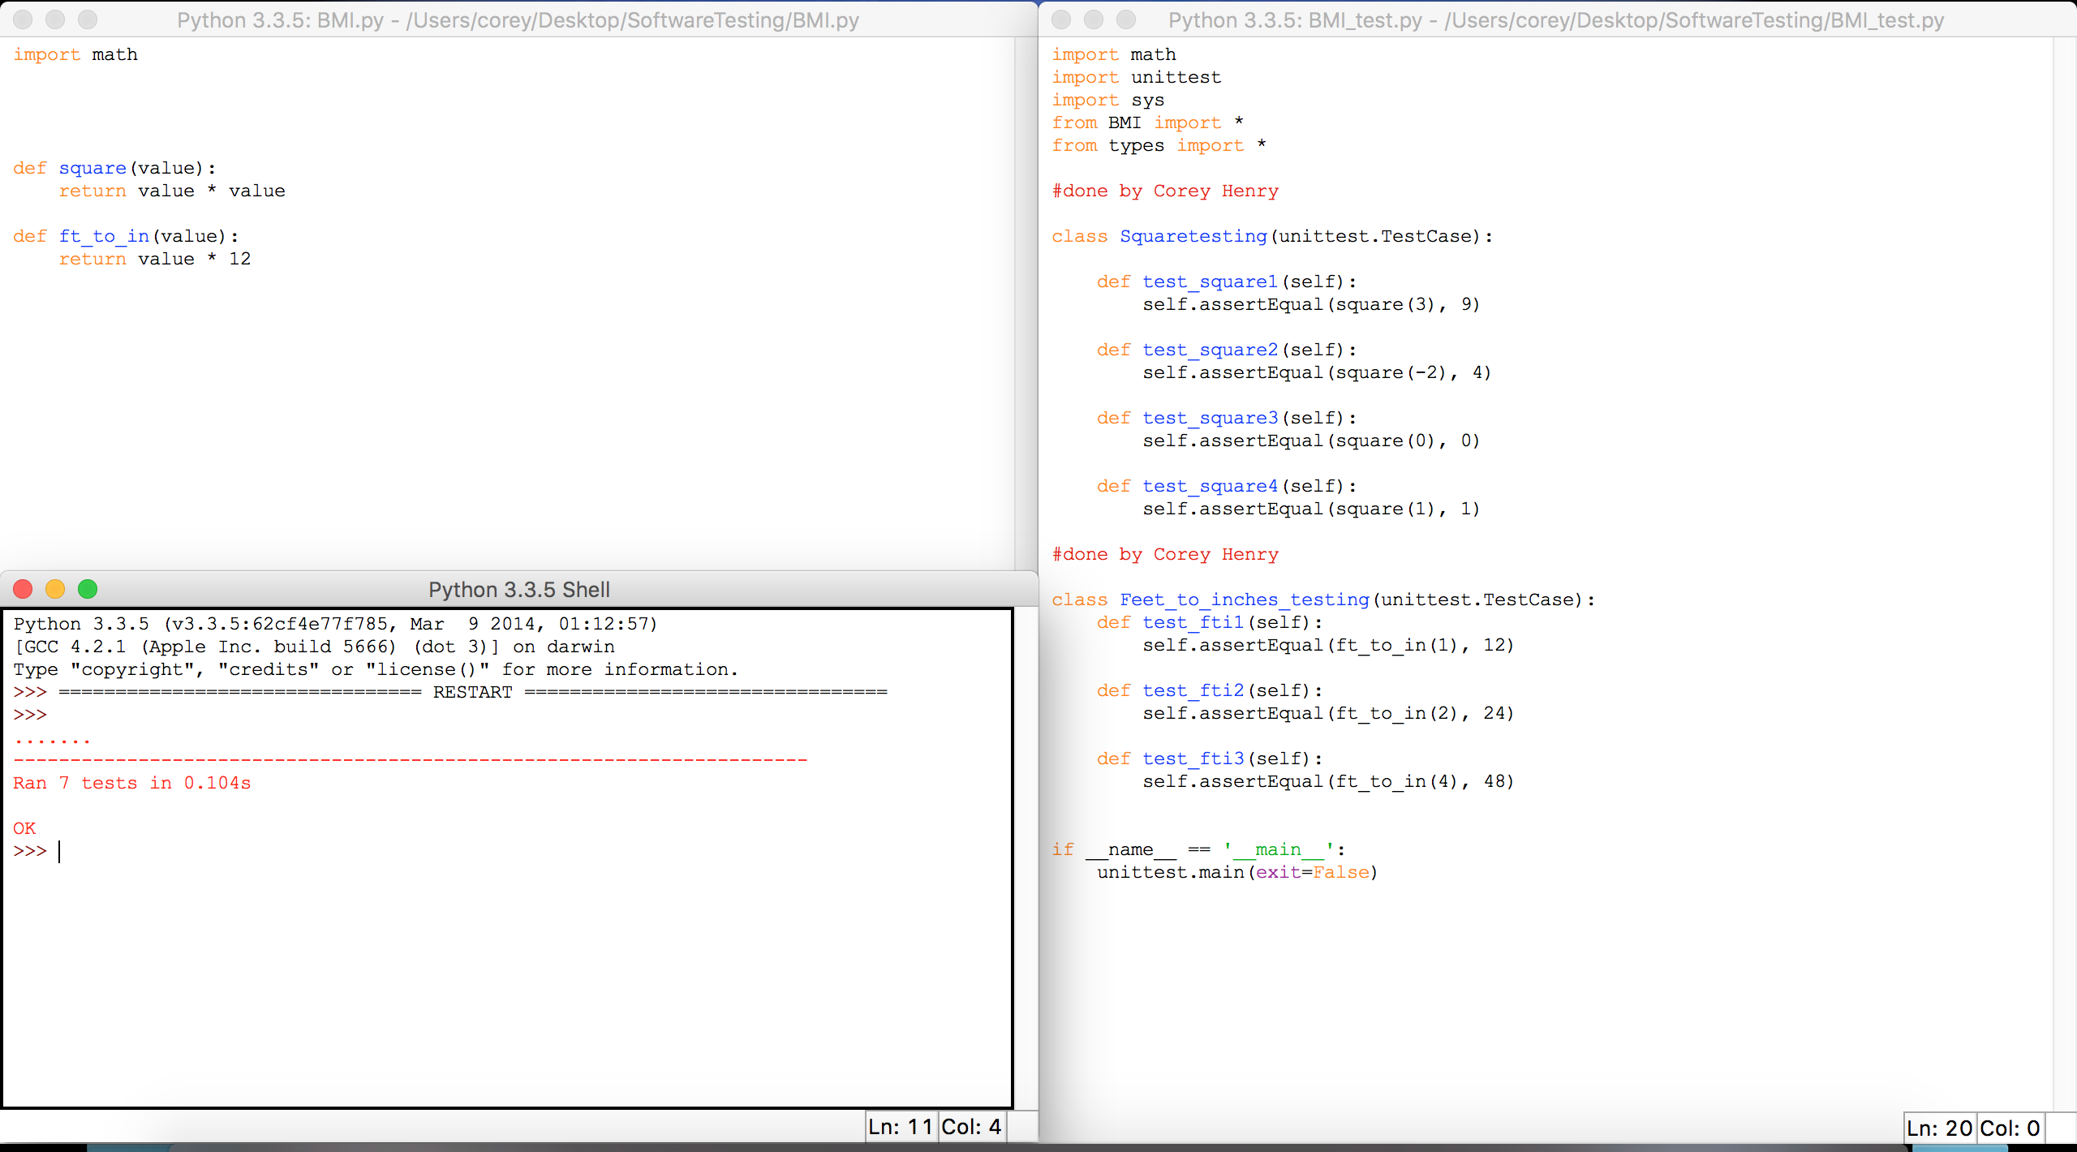
BMI feet to inches test: Fail and Pass

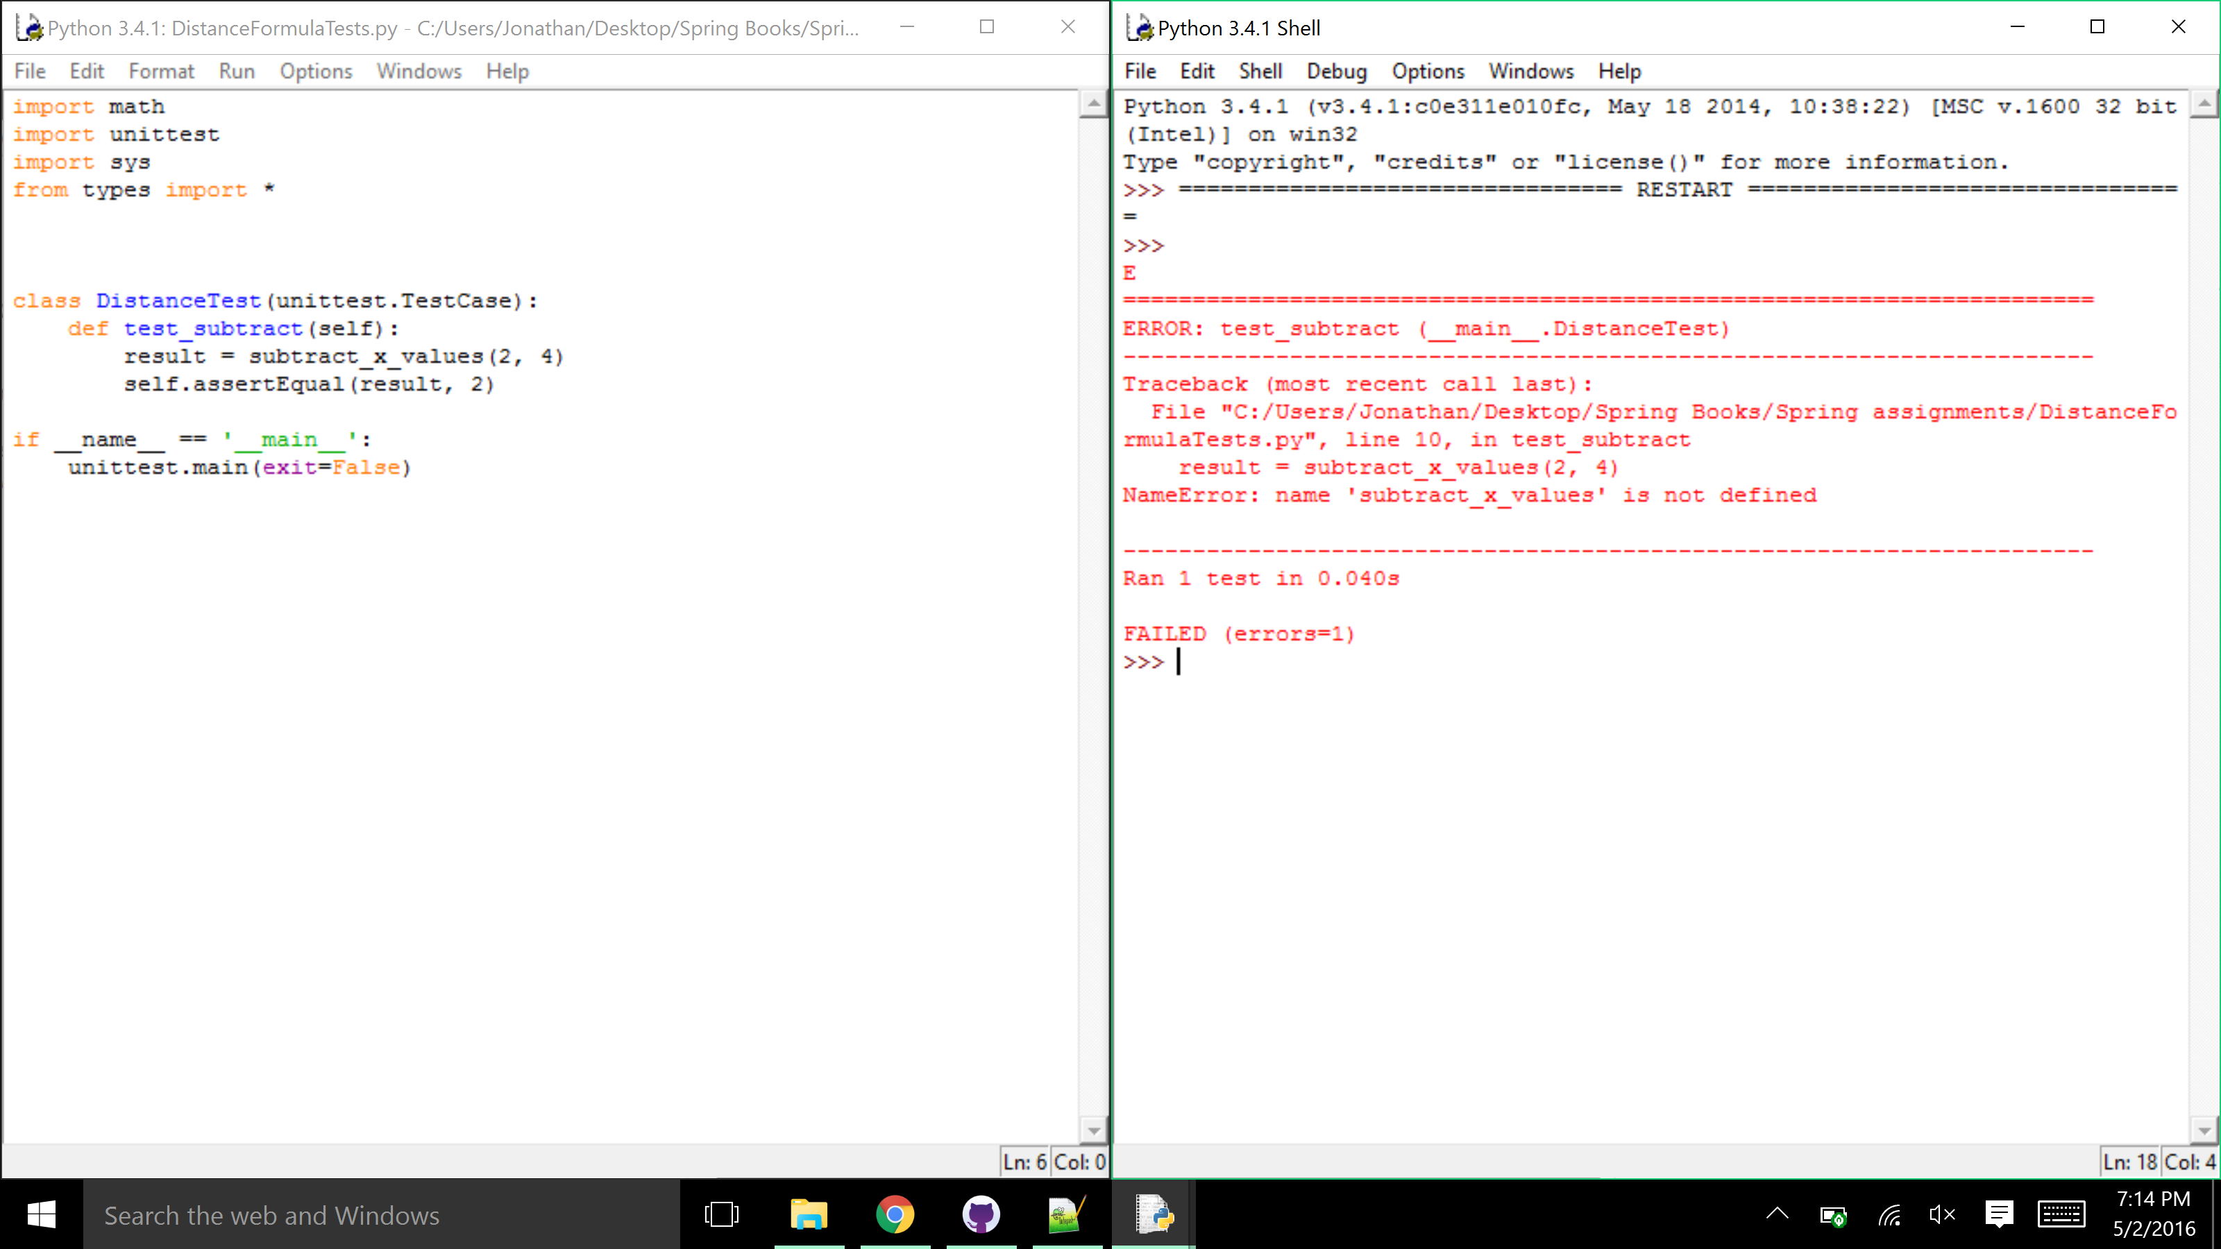
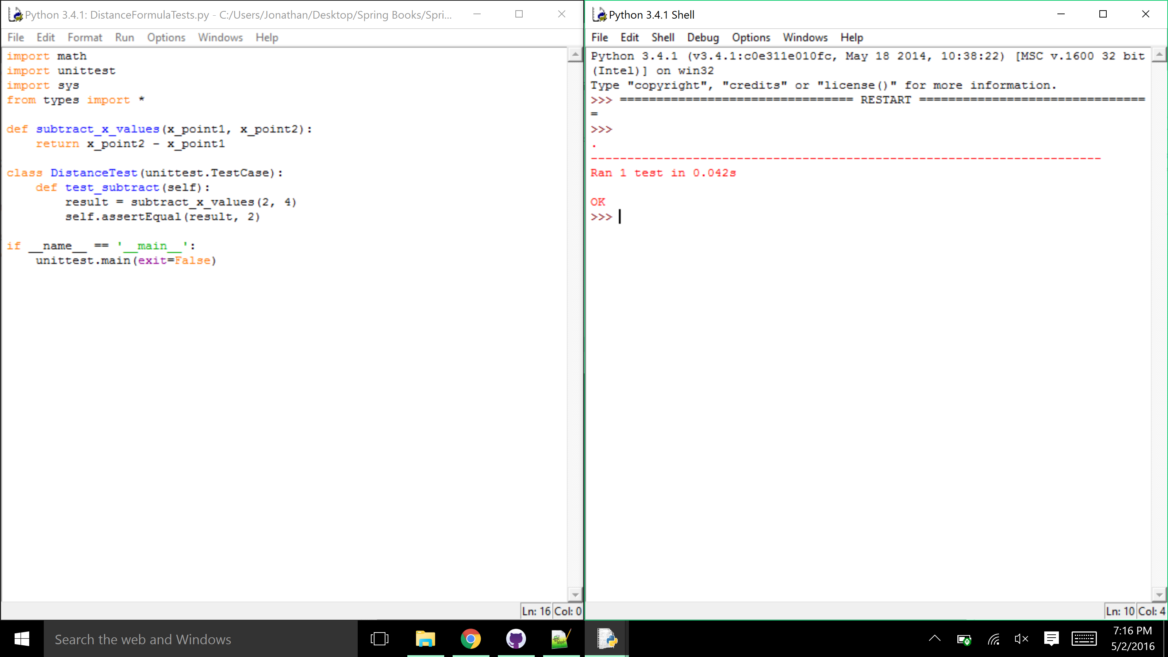

Distance Formula subtracting X values: Fail and Pass

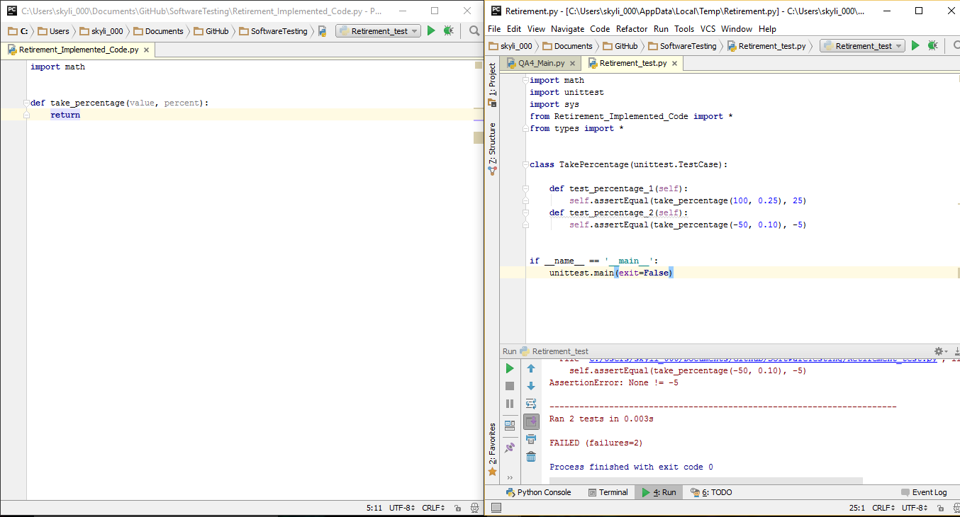
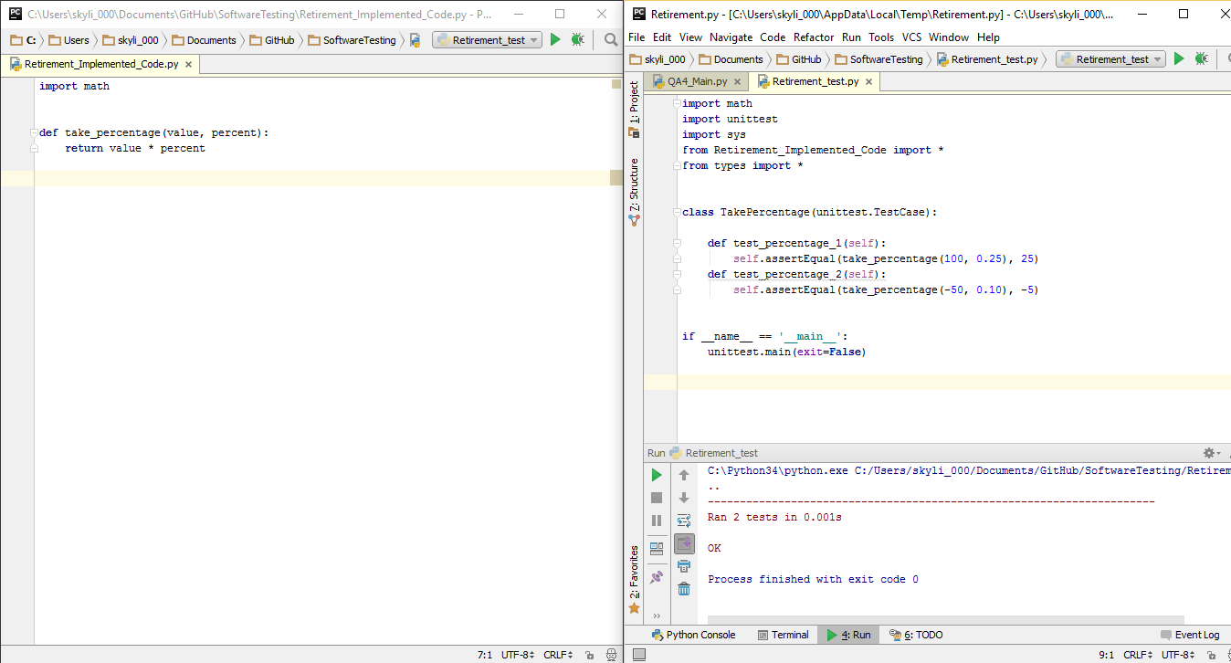

Retirement: Take Percentage function: Fail and Pass

Setup and Use Instructions

- Install latest version of Python

Framework Report

Control Flow

BMI

